Section I: Scenario Demographics

Scenario Title: | Intubation with Missing BVM
Date of Development: | 13/12/2017 (update)
Target Learning Group: | Juniors (PGY 1 – 2) Seniors (PGY ≥ 3) All Groups

Section II: Scenario Developers

Scenario Developer(s): | Dr. N Kester-Greene / Dr A Petrosoniak
Affiliations/Institution(s): | University of Toronto
Contact (Twitter): | @EMeduc / @petrosoniak

Section III: Curriculum Integration

Learning Goals & Objectives
Educational Goal: | To allow learners to practice an approach to RSI in a scenario where there is a problem with the equipment
CRM Objectives: | 1. Communicate effectively with team regarding a plan for RSI  2. Ensure all preparation is complete before initiating a stressful, high-risk procedure
Medical Objectives: | 1. Initiate early sepsis management including ABC support, fluids, and antibiotics  2. Recognize the need for rapid sequence intubation in a hypoxic patient  3. Identify equipment, medication and personnel needed for RSI  4. Perform RSI in a septic, hypoxic patient

Case Summary: Brief Summary of Case Progression and Major Events
A 41-year old male with HIV (not on HAART) presents to the ED with a cough for 10 days, progressive dyspnea and fever. He is hypoxic at triage and brought immediately to the resuscitation room. He has transient improvement on oxygen but then has progressive worsening of his hypoxia and dyspnea. Intubation is required. The team needs to prepare for RSI and identify that the BVM is missing from the room prior to intubation.

Depending on the experience of the participants, the sim instructor may choose to give the team leader a local “pre-intubation checklist” prior to starting the scenario.

References
Marx, J. A., Hockberger, R. S., Walls, R. M., & Adams, J. (2013). Rosen's emergency medicine: Concepts and clinical practice. St. Louis: Mosby.
Nickson, C. (2015). Rapid sequence Intubation (RSI). Life in the Fast Lane. Retrieved from: https://lifeinthefastlane.com/ccc/rapid-sequence-intubation/
PulmCCM. (2013). Intubation Checklists in the ICU and ED. Can They Save Lives? PulmCCM. Retrieved from: https://pulmccm.org/review-articles/emcrits-intubation-checklist-is-it-bigger-than-yours/
Hardy, G., & Horner, D. (2016). Best Bets: Should Real Resuscitationists Use Airway Checklists? Emerg Med J. Vol 33(6):439-41.

Section IV: Scenario Script

A. Scenario Cast & Realism
Patient: | Computerized Mannequin |  |  |  |  | Realism:  Select most important dimension(s) |  |  | Conceptual
 | Mannequin |  |  |  |  |  |  |  | Physical
 | Standardized Patient |  |  |  |  |  |  |  | Emotional/Experiential
 | Hybrid |  |  |  |  |  |  |  | Other:
 | Task Trainer |  |  |  |  |  |  |  | N/A
Confederates | Brief Description of Role
Nurse | To assist at bedside and cue learners to patient’s status.
B. Required Monitors
EKG Leads/Wires |  |  | Temperature Probe |  |  |  | Central Venous Line
NIBP Cuff |  |  | Defibrillator Pads |  |  |  | Capnography
Pulse Oximeter |  |  | Arterial Line |  |  |  | Other:
C. Required Equipment
Gloves |  |  | Nasal Prongs |  |  |  | Scalpel
Stethoscope |  |  | Venturi Mask |  |  |  | Tube Thoracostomy Kit
Defibrillator |  |  | Non-Rebreather Mask |  |  |  | Cricothyroidotomy Kit
IV Bags/Lines |  |  | *Bag Valve Mask* (removed from room prior to scenario) |  |  |  | Thoracotomy Kit
IV Push Medications |  |  | Laryngoscope |  |  |  | Central Line Kit
PO Tabs |  |  | Video Assisted Laryngoscope |  |  |  | Arterial Line Kit
Blood Products |  |  | ET Tubes |  |  |  | Other:
Intraosseous Set-up |  |  | LMA |  |  |  | Other:
D. Moulage
One IV line in situ.

E. Approximate Timing
Set-Up: |  | 3 min |  | Scenario: | 12 min |  |  | Debriefing: |  | 15 min

Section V: Patient Data and Baseline State

A. Clinical Vignette: To Read Aloud at Beginning of Case
You are working in a large community ED. The triage nurse tells you that she has just put a patient in the resuscitation room. He is a 41-year old man with HIV. He is known to be non-compliant with his anti-retrovirals. He noticed progressive shortness of breath over 3-4 days and has had a dry cough for 10 days. His O₂ sat was in the 80s at triage.
B. Patient Profile and History
Patient Name: Tony Schwartz |  |  |  |  |  | Age: 41 |  |  |  |  |  |  |  | Weight: 80kg
Gender: M F |  |  |  |  |  | Code Status: Full Code
Chief Complaint: Dyspnea
History of Presenting Illness: He noticed progressive shortness of breath over 3-4 days and has had a dry cough for 10 days. He thinks last night he had a fever. No recent travel. No sick contacts.
Past Medical History: |  | HIV x 12 years |  |  |  |  | Medications: |  |  |  |  | None
 |  |  |  |  |  |  |  |  |  |  |  | No HAART (worried about side effects)
Allergies: None
Social History: Lives alone. Software tech. Occasional beer, MJ. No IVDU.
Family History: Non-contributory
Review of Systems: |  | CNS: |  |  | Nil
 |  | HEENT: |  |  | Nil
 |  | CVS: |  |  | Nil
 |  | RESP: |  |  | Tachypneic, increased work of breathing, cough
 |  | GI: |  |  | Nil
 |  | GU: |  |  | Nil
 |  | MSK: |  |  | Nil |  |  |  |  |  |  |  | INT: |  | Nil
C. Baseline Simulator State and Physical Exam
No Monitor Display |  |  |  | Monitor On, no data displayed |  |  |  |  |  |  | Monitor on Standard Display
HR: 105/min |  |  | BP: 110/70 |  |  |  |  | RR: 30/min |  |  |  |  |  |  | O₂SAT: 84% on RA
Rhythm: Sinus tach |  |  | T: 38.3ºC |  |  |  |  | Glucose: 6.2mmol/L |  |  |  |  |  |  | GCS: 15 (E4 V5 M6)
General Status: Alert but having respiratory distress. 2-3 word dyspnea.
CNS: | Alert, able to give history.
HEENT: | Nil
CVS: | No murmur
RESP: | Bilateral coarse crackles. Increased RR and WOB.
ABDO: | Soft and non-tender
GU: | Nil
MSK: | Nil |  |  |  |  |  |  |  | SKIN: | Nil

Scenario States, Modifiers and Triggers
Patient State | Patient Status | Learner Actions, Modifiers & Triggers to Move to Next State
1. Baseline State  Rhythm: Sinus  HR: 105/min  BP: 110/70  RR: 30/min  O₂SAT: 84%  T: 38.3ºC | Able to answer questions. 2-3 word dyspnea. | Learner Actions  - Apply monitors  - Apply O₂ (NRB)  - Obtain 2nd IV  - Bloodwork including blood cultures, VBG, lactate  - IV saline 1-2L bolus  - Call for pCXR  - Give broad spectrum antibiotics +/- septra | Modifiers  Changes to patient condition based on learner action  - NRB placed O2 90%  - NS bolus BP 125/80  Triggers  For progression to next state  - All actions complete or 5 min into case 2. Hypoxia
2. Hypoxia  Rhythm: Sinus  HR: 105/min  BP: 110/70  RR: 30/min  O₂SAT: 80% | SpO2 starts dropping despite mgmt.  Patient progressively becomes more drowsy. | Learner Actions  - Call RT/BiPAP  - 2nd IV (if not done)  - Airway assessment  - Ask for RSI meds  - Ask for RSI equipment  - Notice BVM is missing and request before proceeding  - +/- Nasal prongs for apneic oxygenation | Modifiers  - O2 drops 2% per minute  - If the hypoxia is not noticed, RN to prompt “his sats are getting really low”  - If notice missing BVM RN to retrieve one  Triggers  - RSI Meds given 3. Intubation
3. Intubation  Rhythm: Sinus  HR: 105/min  BP: 110/70  RR: 30/min  O₂SAT: 65% | Acute drop in spO2 on induction | Learner Actions  - Bag patient with BVM  - Intubation  - Confirm tube placement | Modifiers  - BVM O2 95%  Triggers  - Intubation attempt without using BVM first or no BVM at bedside 4. PEA arrest  - BVM then intubate 5. Resolution
4. PEA arrest  Rhythm: Junctional  HR: 35 (no pulse)  BP: 0  RR: BMV rate (10-12)  O2SAT: 0  EtCO2: 10 (15-20 if high quality CPR) | Patient pulseless and non-responsive. | Learner Actions  - Recognize PEA arrest and start CPR  - Run resus per ACLS  - Epi 1mg q3-5min  - Intubation | Modifiers  - If no intubation after epi x2, RN to prompt “maybe we should intubate the patient”  Triggers  - Intubation 5. Resolution
5. Resolution  Rhythm: sinus  HR: 90/min  BP: 110/75  RR: 12/min (vented)  O₂SAT: 95%  EtCO2: 40 | Patient intubated and sedated. | Learner Actions  - Call ICU  - Start sedation  - Call for pCXR | Triggers  - Call ICU END OF CASE
Section VI: Scenario Progression

Section VII: Supporting Documents, Laboratory Results, & Multimedia

Laboratory Results
No results provided during case.

Images (ECGs, CXRs, etc.)
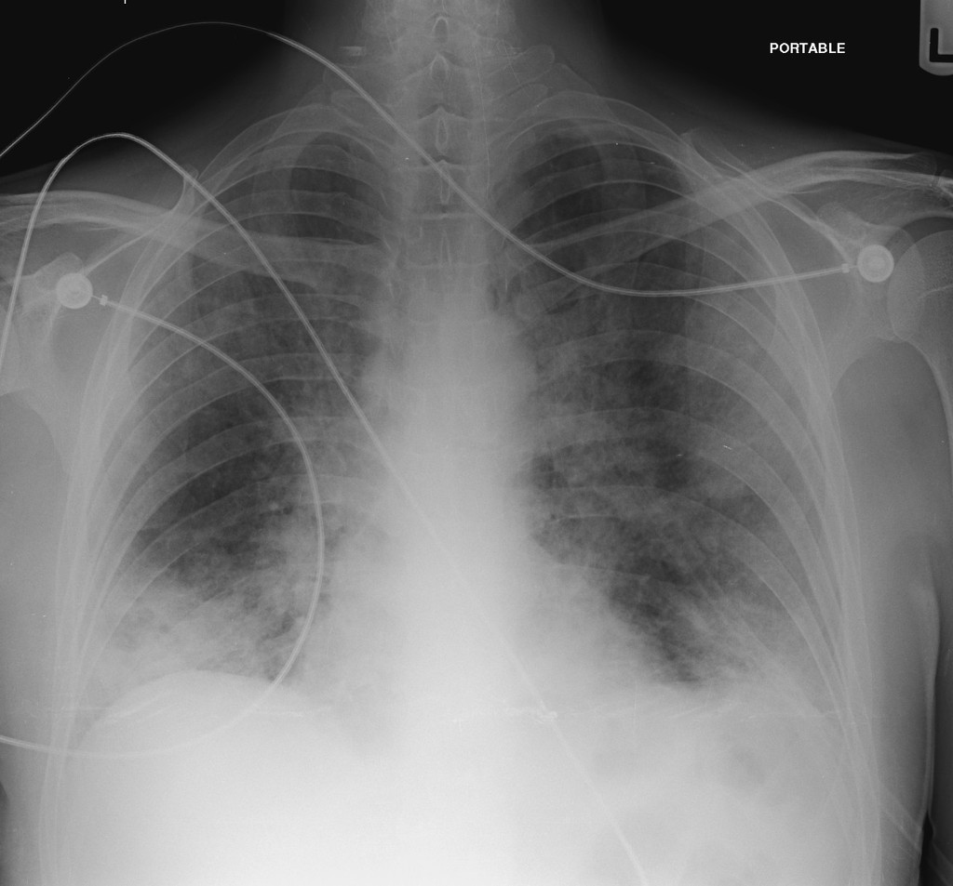
(CXR source: https://radiopaedia.org/cases/35823)

Ultrasound Video Files (if applicable)
None

Section VIII: Debriefing Guide

General Debriefing Plan
Individual |  | Group | With Video | Without Video
Objectives
Educational Goal: | To allow learners to practice RSI in a scenario where there is a problem with the equipment
CRM Objectives: | 1. Communicate effectively with team before and during RSI  2. Ensure all preparation is complete before initiating a stressful, high-risk procedure
Medical Objectives: | 1. Initiate early sepsis management including ABC support, fluids, and antibiotics  2. Recognize the need for rapid sequence intubation in a hypoxic patient  3. Identify equipment, medication and personnel needed for RSI  4. Perform RSI in a septic, hypoxic patient
Sample Questions for Debriefing
1. What are the indications for intubation? Which were present for this patient?
2. What was you approach to intubation in this patient? What factors did you consider when choosing meds and equipment?
3. What are some ways to ensure that you are prepared for intubation? What tools/checklists have you seen or used?
4. How can the team members best work together during an intubation?
5. How does management of sepsis change in an immunocompromised patient? Are there any specific treatment differences to consider in HIV?
Key Moments
1. Recognize and treat sepsis in an immunocompromised patient
2. Decision to intubate for hypoxic respiratory failure
3. Assemble all equipment prior to intubation attempt
4. Recognize peri-intubation hypoxia and use BVM

